Name : Sakthi Manoj R Reg No : 192324236
PROGRAM 6
Create an R List Containing Vectors, Matrices, and Functions
Aim:
To create an R list containing vectors, matrices, and functions and display its contents.
Procedure:
Step 1: Open RStudio or R console on your system.
Step 2: Create a numeric vector and store it in a variable.
Step 3: Create a matrix by arranging numbers into specified rows and columns.
Step 4: Define a simple function that performs a mathematical operation, such as squaring a number.
Step 5: Combine the vector, matrix, and function into a single list using the list function.
Step 6: Assign appropriate names to each component in the list for better readability.
Step 7: Display the list to view the vector, matrix, and function stored together in one structured object.
Output :
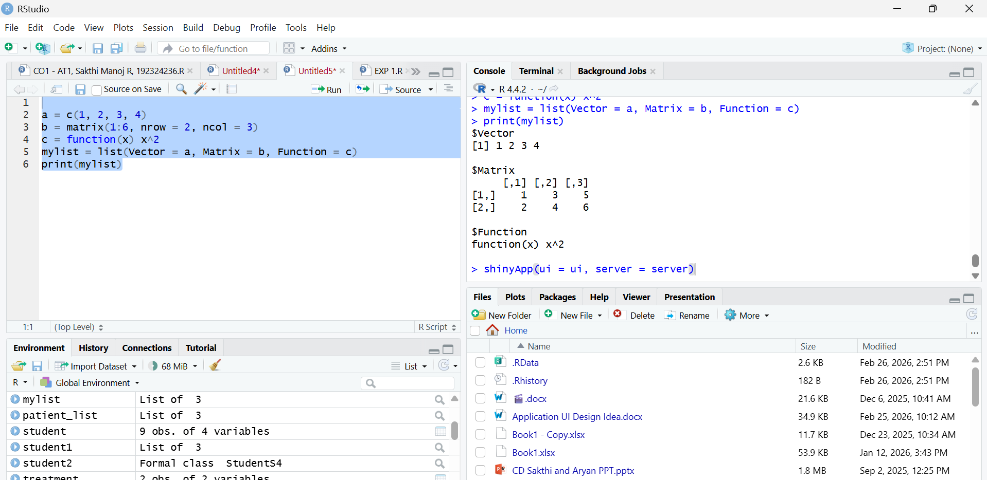

Result:
Hence the output is verified successfully.

